**HW 23 SOLID PRINCIPLES**

SIGLE RESPONSABILITY

* 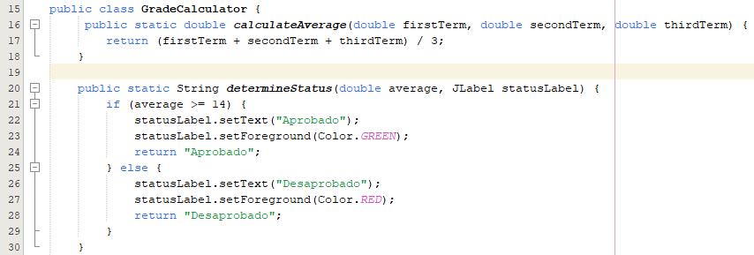**Explanation:** The GradeCalculator class adheres to SRP by having each method focused on a single responsibility. For example, the calculateAverage method only calculates the average of three grades, and the determineStatus method determines the status based on the average. This separation of concerns ensures that each method does only one thing, making the class easier to maintain and understand.

**Open/Closed Principle (OCP):**

* **Explanation:** The determineStatus method is an example of OCP. It is open for extension but closed for modification. If you wanted to add more statuses (e.g., "Excellent" for averages over 18), you could extend the logic without modifying the existing method by perhaps adding another condition or creating a new method that overrides the existing behavior. This approach avoids changing the existing code and reduces the risk of introducing bugs.



**Open/Closed Principle (OCP)**:

* **Explicación**: La clase ValidateData está abierta para la extensión pero cerrada para la modificación. Si en el futuro se necesita agregar una nueva validación, se puede crear un nuevo método sin necesidad de modificar los ya existentes, lo cual respeta este principio.

